​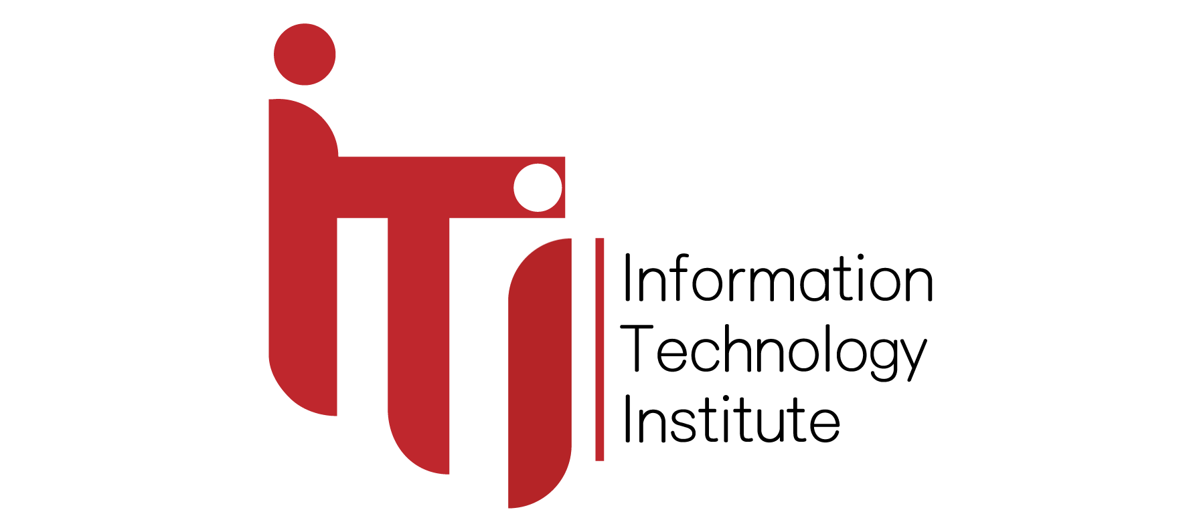

Information Technology Institute

Power BI Development Track

**ITI Examination System**

**Adham Abd Elnasser**

**Ahmed Ibrahim**

**Nader John**

**Noreen Essam**

**Ziad Nasser**

## ABSTRACT

To evaluate and enhance the effectiveness of academic qualifications, it is crucial to have a reliable system that determines whether these qualifications are applied appropriately. For this purpose, we propose an examination system designed to measure students’ comprehension and mastery of specific subjects or courses.

The outcomes of these exams can highlight strengths and weaknesses, guiding future training and development initiatives. Additionally, with the growing popularity of online learning and freelance opportunities, such systems can help track and assess students’ acquired skills more efficiently.

In essence, an examination system represents a vital element in the educational evaluation process. It ensures that learning standards are upheld and that students receive fair, accurate, and constructive feedback on their academic performance.

## INTRODUCTION

The rapid evolution of technology is reshaping the world at an extraordinary pace. As innovation continues to advance daily, it has become essential to adapt, understand, and evaluate our capabilities within this constantly changing environment. In this context, the examination system plays a vital role in accurately measuring learners’ knowledge, identifying strengths and weaknesses, and supporting data-driven decisions related to skill development and continuous improvement—particularly in fields such as data science and other technology-based disciplines.

The proposed system will be organized into departments that include instructors responsible for guiding students throughout their learning journey and preparing them for future careers. The offered courses are aligned with modern technological trends and emphasize the importance of data-driven skills, including Python, SQL and Data Warehousing.

The system can include multiple exam formats such as multiple-choice and true/false questions, which allow for efficient assessment and help reduce stress, promoting better mental well-being among learners.

Through continuous testing and feedback, students can recognize areas that need further development, refine their learning focus, and remain up to date with emerging technologies and best practices. Once feedback is given, learners receive their grades and can determine whether to revisit specific course content or advance to higher levels. Ultimately, completing all courses and assessments leads to certification—an acknowledgment of proficiency that enhances employability and provides organizations with qualified professionals ready to meet industry demands.

## IMPLEMENTATION LIFE CYCLE

The implementation life cycle is an iterative process designed to ensure that the system fulfills all specified requirements. It includes several phases, starting from developing entity-relationship diagrams (ERDs) and creating the database structure, followed by mapping entities and relationships, and then performing detailed data modelling to ensure consistency and integrity. Finally, the process concludes with generating reports and building interactive dashboards that transform data into meaningful insights.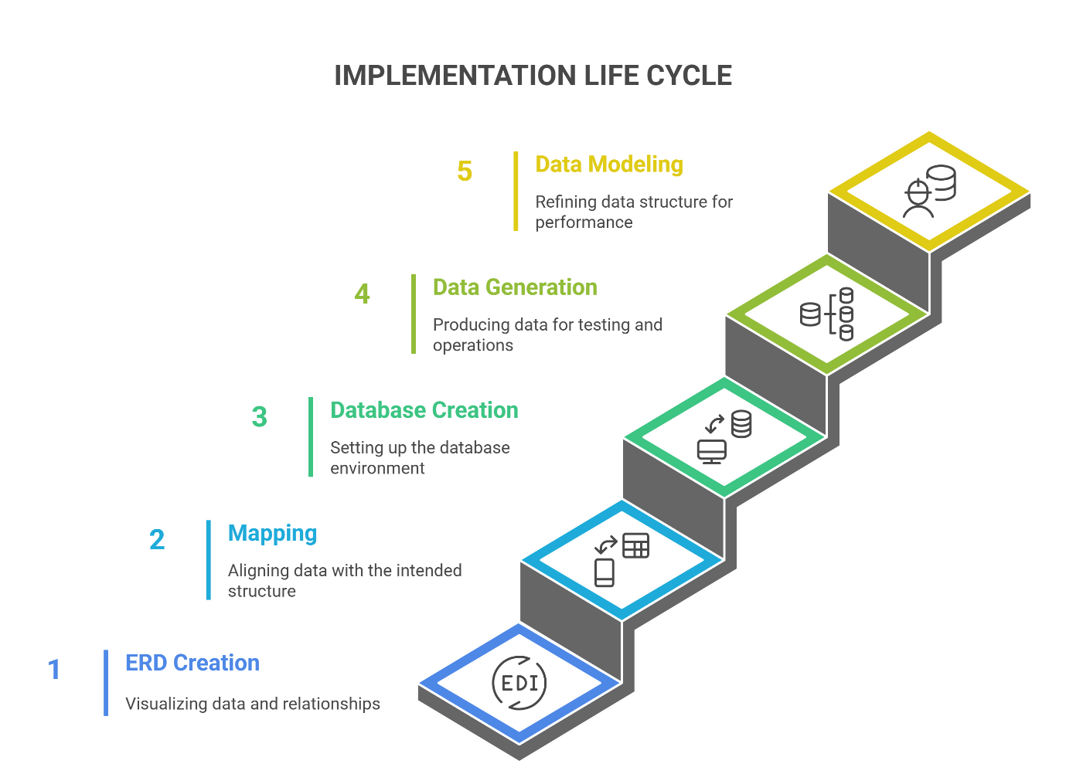

**ERD (Entity Relationship Diagram):**In this phase, we designed the entity-relationship diagram to define the main entities, their attributes, and the relationships between them. This step provided a clear conceptual view of how data flows within the system.

**Mapping:**After completing the ERD, we performed the mapping process to translate the conceptual model into a logical database structure. This included defining primary and foreign keys, establishing relationships between tables, and preparing the foundation for database creation and further data modeling.

**Database creation:** In this stage, we implemented the database schema by writing and executing the required SQL scripts. The system components were then integrated into a functional database environment, followed by testing to verify that it effectively handles exam data, student responses, and related operations.

**Data Generation:**

In this phase, we used Python alongside several artificial intelligence platforms to generate the required dataset. These AI-based tools were employed to create realistic and diverse data that simulate actual exam results, student behaviors, and course interactions. This helped us obtain high-quality synthetic data suitable for testing and system evaluation.

**Data Modelling:**

In this phase, we implemented a Snowflake Data Model designed to organize and manage complex academic data efficiently.

The model ensures normalization by minimizing redundancy and maintaining strong referential integrity.

This structure enables better analytical reporting and scalability for future data expansion.

ERD (Entity Relationship Diagram)

Examination system ERD includes entities such as Student, Intake, Department, questions, exams, Courses, and other entities, then relation between each other.

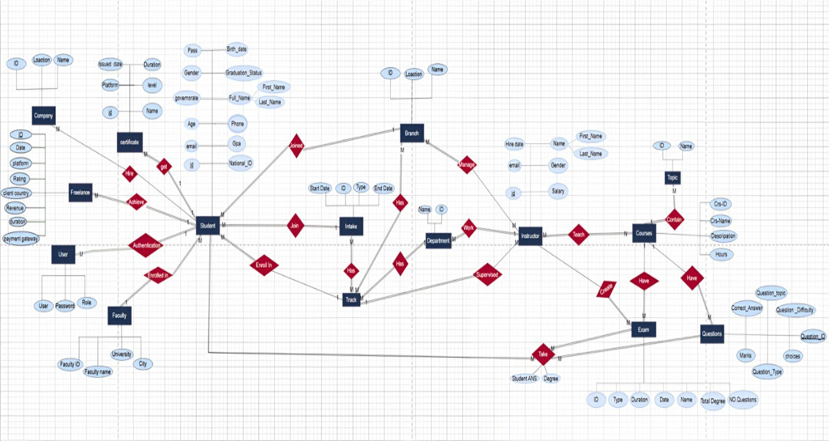

MAPPING

Mapping in the examination system refers to the process of creating a correspondence or association between different entities or attributes in the system needed to implement in the SQL Server Management Studio.

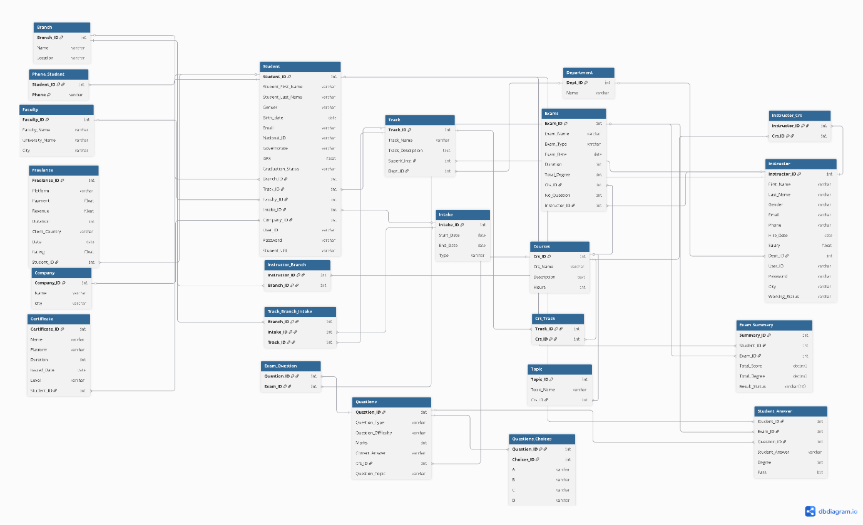

Data Base Creation

In this phase, we implemented the database by creating all necessary tables, relationships, and constraints based on the ERD and mapping design. SQL scripts were used to build the database structure, define primary and foreign keys, and ensure data integrity.

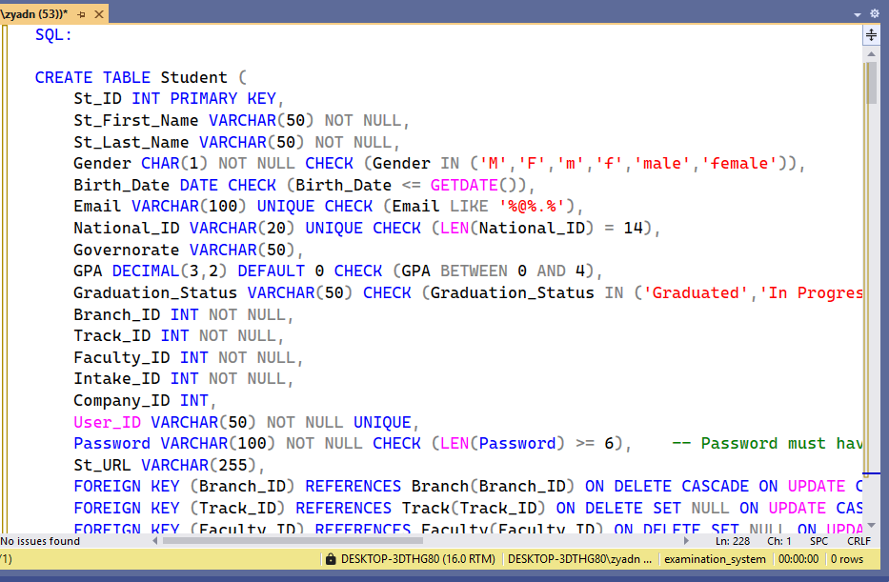

**Stored Procedures:**  
In this phase, we created stored procedures for each table in the database to handle the main data operations. These procedures were developed to perform Insert, Update, and Delete actions efficiently and securely. Using stored procedures helped improve performance, maintain data consistency, and simplify interaction between the application and the database by centralizing all SQL logic in one place.

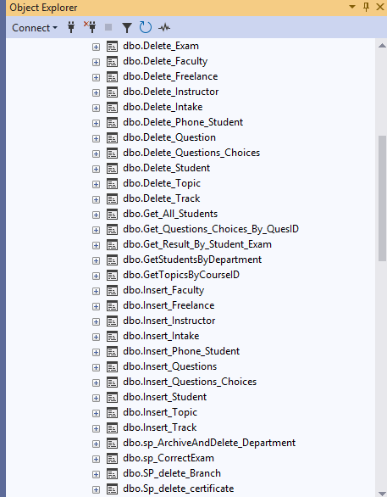

Insertion Stored Procedure:  
  
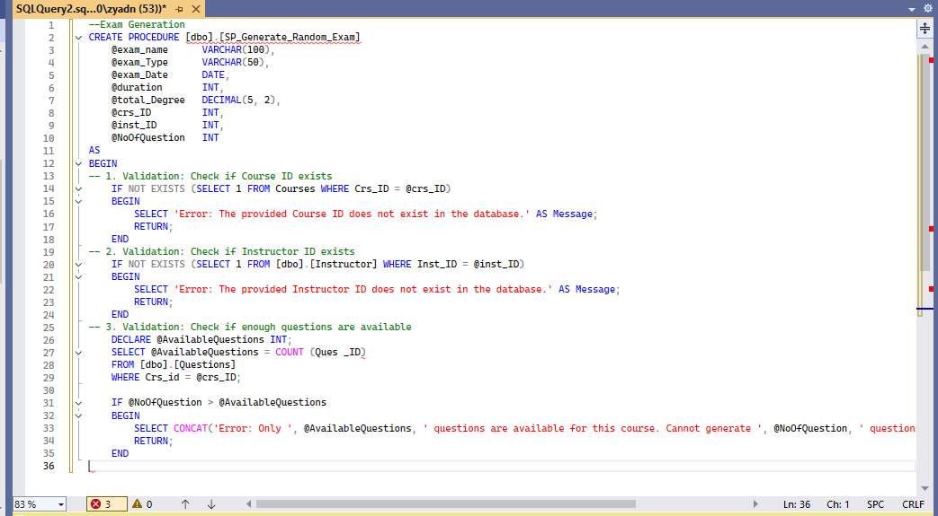

Update Stored Procedure:

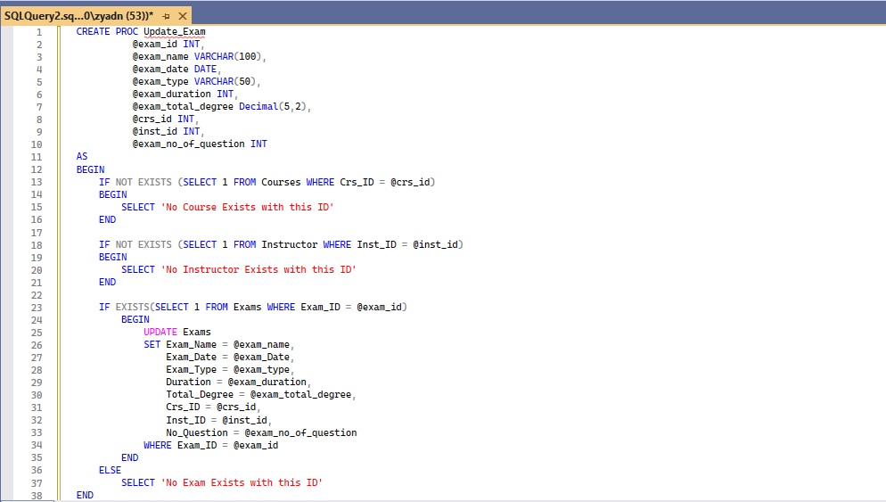

Delete Stored Procedure:

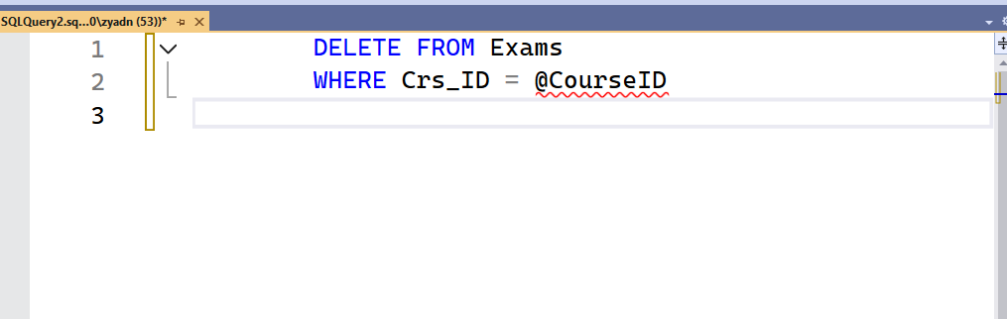

**Views:**

In this phase, we created several database views to simplify data retrieval and improve system performance. Each view was designed to combine data from multiple tables, making it easier to generate reports and present meaningful insights for students, instructors, and administrators.

Additionally, the views played an important role in the data modelling process, as they were used to organize and structure the data in a way that supports analysis and visualization within dashboards and reports. This approach helped ensure consistency between the database and the analytical layer of the system while maintaining data security and integrity.

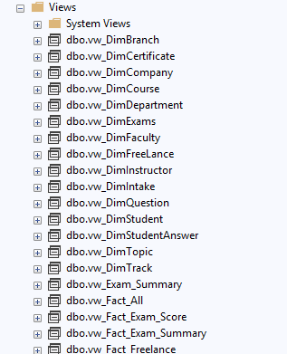

Department View:

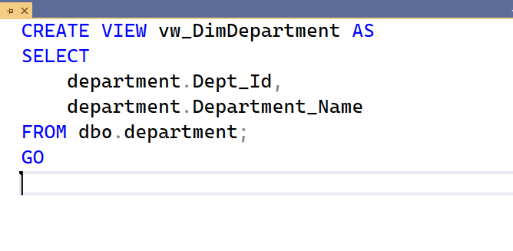Topic View:

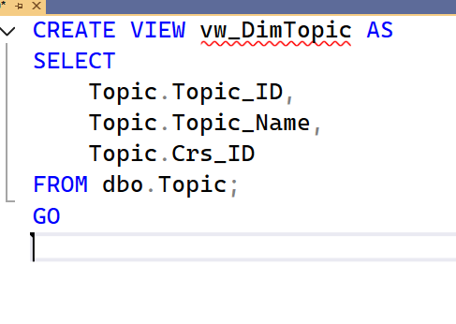

## **Data Modelling**

## The Snowflake schema consists of multiple interrelated tables that represent entities like Students, Instructors, Faculties, Branches, Courses, Departments, and Social Media Activity.

## Each dimension is normalized into smaller related tables to reduce duplication and enhance data consistency.

## For example, the Student table connects to entities such as Faculty, Branch, Company, and Exam Activity, providing a comprehensive academic overview.

## Similarly, the Instructor and Course tables are linked through associative tables to handle many-to-many relationships efficiently.

## The design follows a clear hierarchy: Fact tables capture measurable events like Exam Results or Activity Participation, while Dimension tables store descriptive attributes such as Faculty Name or Course Details.

## This approach enables efficient querying, flexible reporting, and integration with BI tools like Power BI. By adopting the Snowflake structure, the system achieves higher data integrity, easier maintenance, and optimized performance for analytical operations

## .

## 

## **SQL Service Reporting Services Report (SSRS) Instructor Course Report** A stored procedure is created to generate an Instructor Course Summary Report by taking the Instructor ID as a parameter. It returns the instructor’s name, the course they teach, and the number of enrolled students. **Topic by Course** The Topic by Course Report uses a stored procedure that takes the Course ID as input and returns the course and its topics.

## **Course Grades by Student** A stored procedure is created to generate the Student Exam Report by taking the Student ID as a parameter. It returns the Exam ID, Exam Name, Course Name, Student Score, and Result Status.

## 

**Exam Questions**A stored procedure is created to generate the Exam Report by taking the Exam Number as a parameter. It returns the exam questions and their corresponding answers.

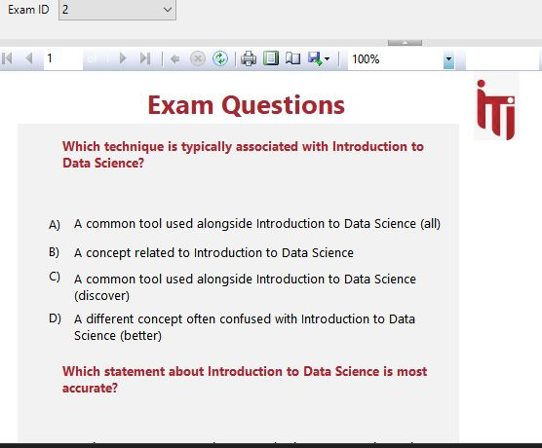

## **Student by Department** A stored procedure is created to generate the Students by Department Report by taking the Department ID as a parameter. It returns the department name and the list of students enrolled in it with information about each student. **Student Answer by Exam ID & Student ID** The Student Answer Report uses a stored procedure that takes the Exam ID and Student ID as input and returns the questions and student answers. **Dashboard Overview** Analyze the examination system as a whole and explain the numbers of instructors, Branches, Tracks, Exams, etc.

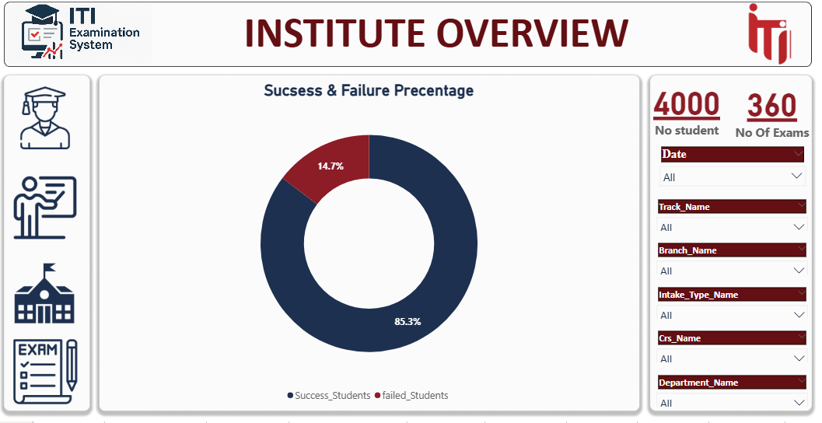

**Student Overview 1**

Displays the number of students enrolled in different departments and Governorate.

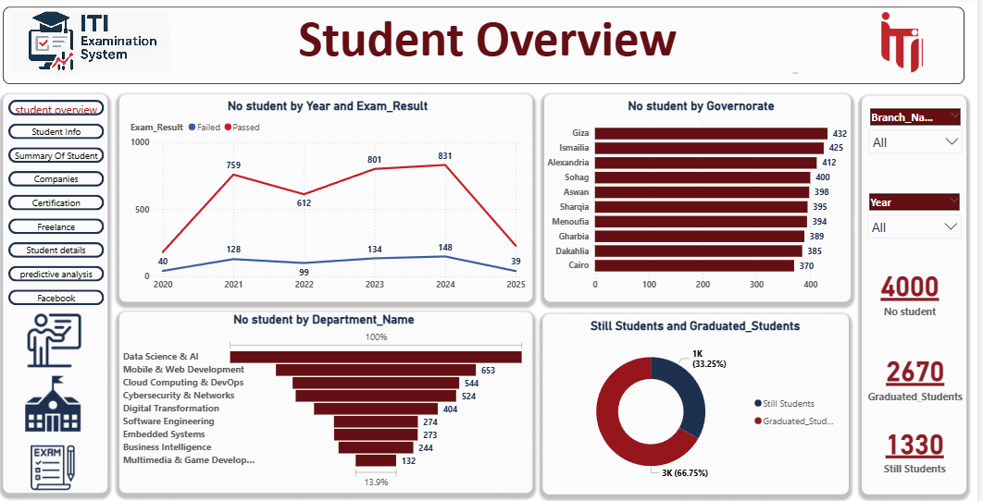

**Student Overview 2**

Displays the number of students by gender, track and intake.

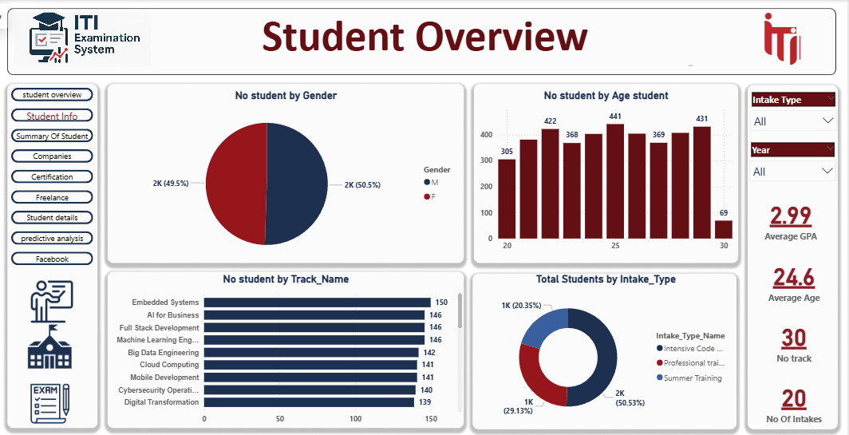

**Student Overview 3**

represent the relationship between students, their branches, departments, intakes, and tracks, helping to analyze academic distribution and learning paths.

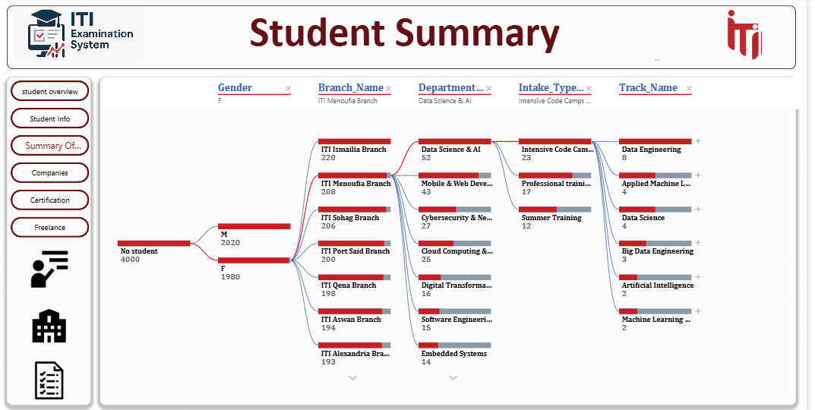

**Company Dashboard**

Measures the engagement level of alumni, such as the number of those hired, No. companies by faculty & Students.

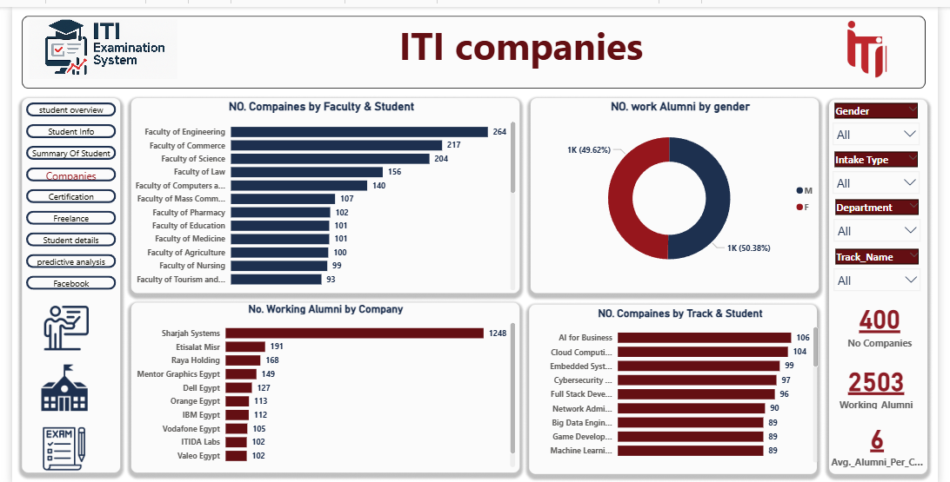

**Certificate Dashboard**

Displays the number of students who completed online Certifications and the names of these Certifications.

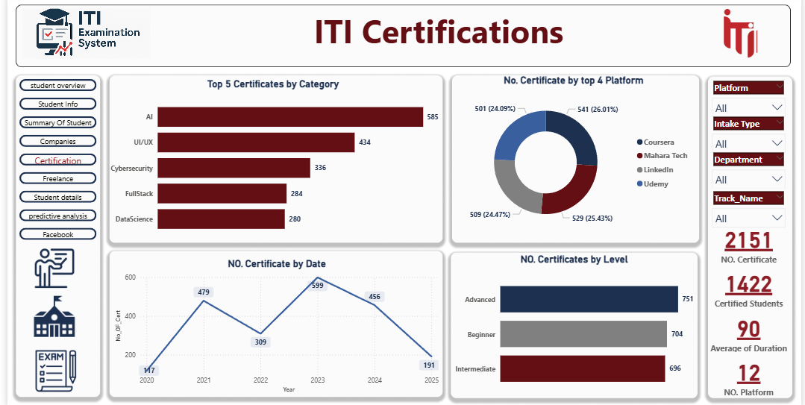

**Freelance Dashboard**

Tracks the number of students who complete freelancing jobs.

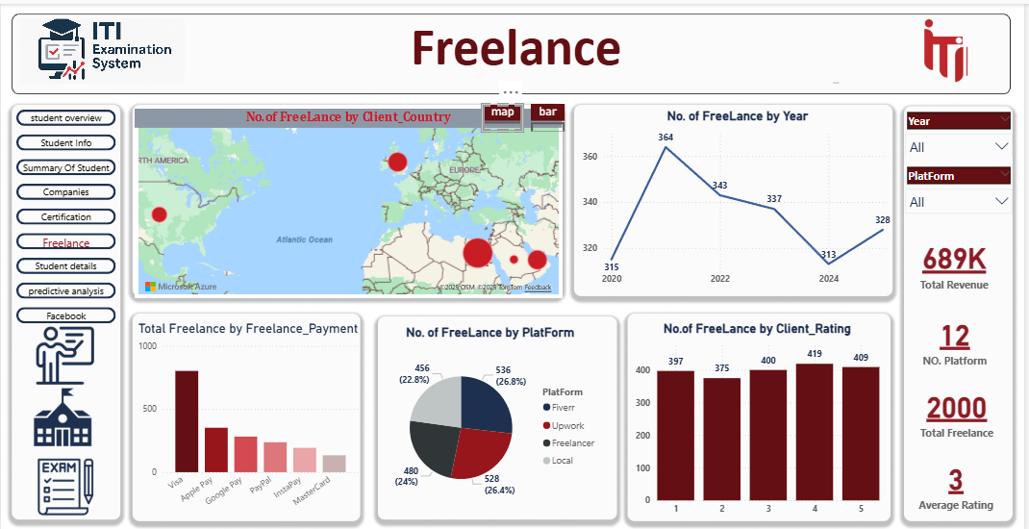

**Instructor Dashboard 1**

Evaluates Instructor performance based on student score, salary, ….etc.

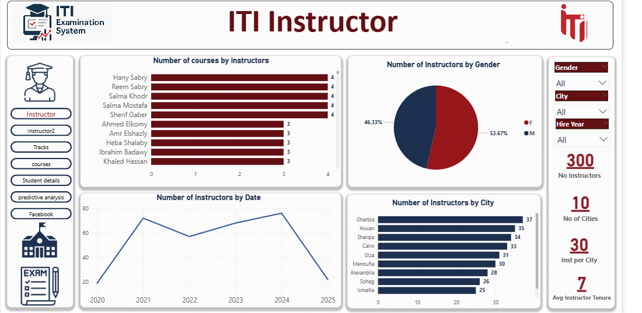

**Instructor Dashboard 2**

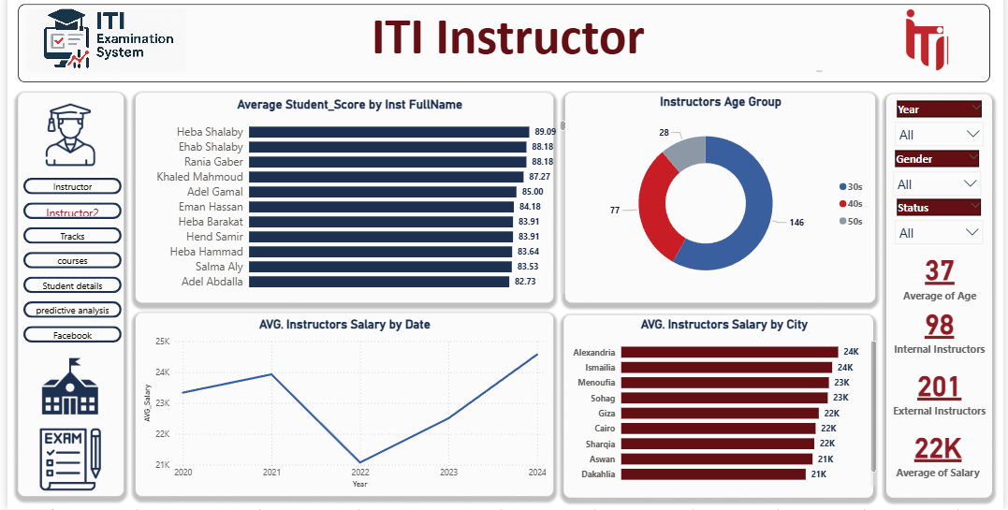

**Tracks Dashboard**

A dashboard was designed to analyze and compare different tracks, showing student distribution, performance levels, and progress across each track.

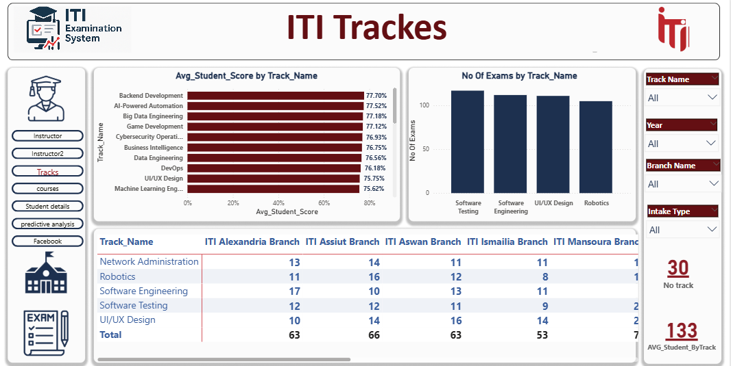

**Course Dashboard**

A dashboard was developed to display insights for each Course, showing average student score, performance trends, and progress comparisons across different courses.

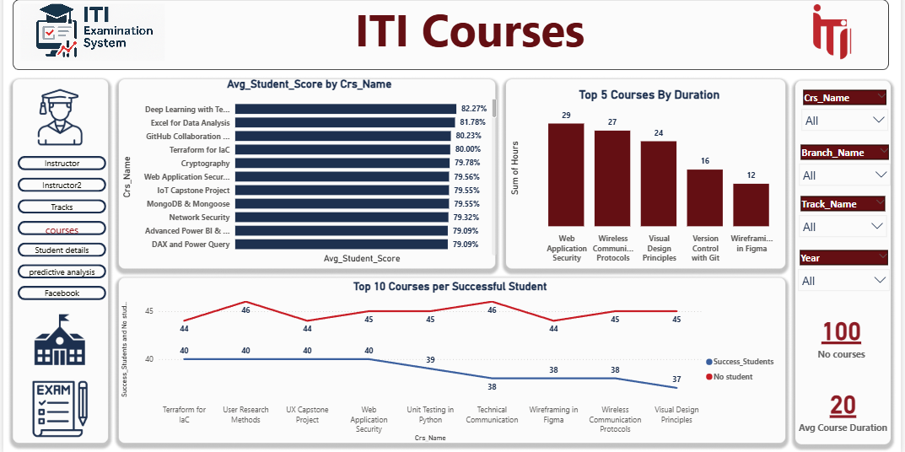

**Branches Dashboard**

A dashboard was created to analyze the performance and distribution of students across different branches, highlighting academic results and enrollment rates.  
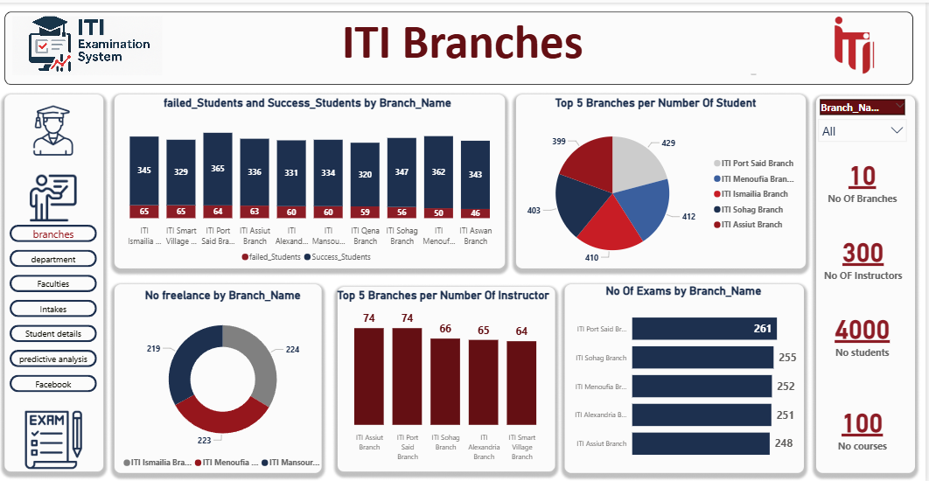

**Department Dashboard**  
Displays the number of departments, the top exams, and number of tracks in each department.

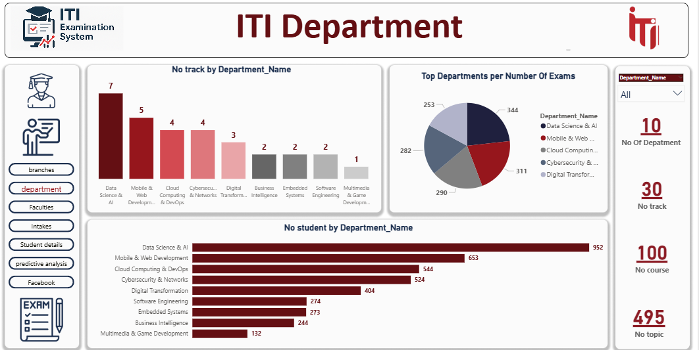

**Faculties & University Dashboard**

A dashboard was designed to provide an overview of the faculties and university performance, showcasing student distribution, academic results.

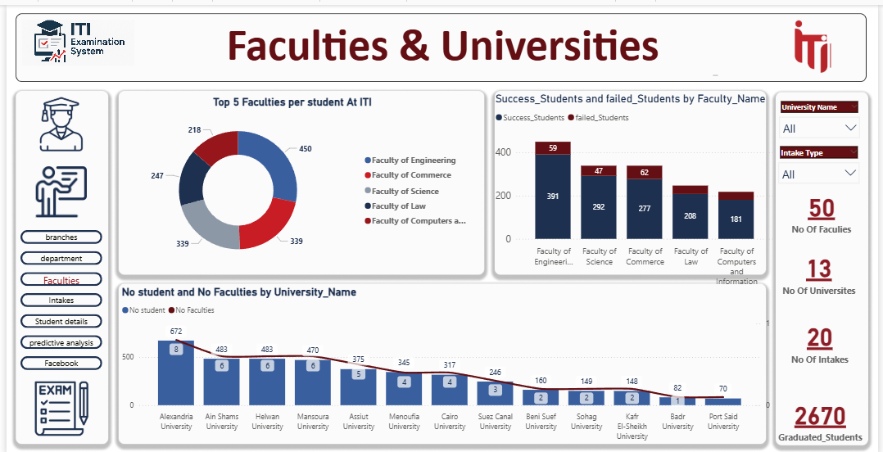

**Intake Dashboard**

A dashboard was developed to display insights for each intake, showing student enrollment, performance trends, and progress comparisons across different tracks.

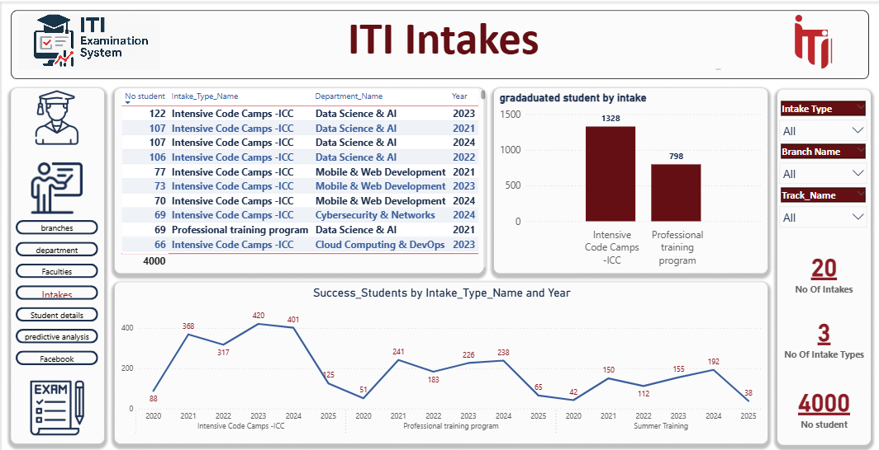

**Questions Dashboard**

A dashboard was developed to analyze exam questions, showing their difficulty levels, correct answer.

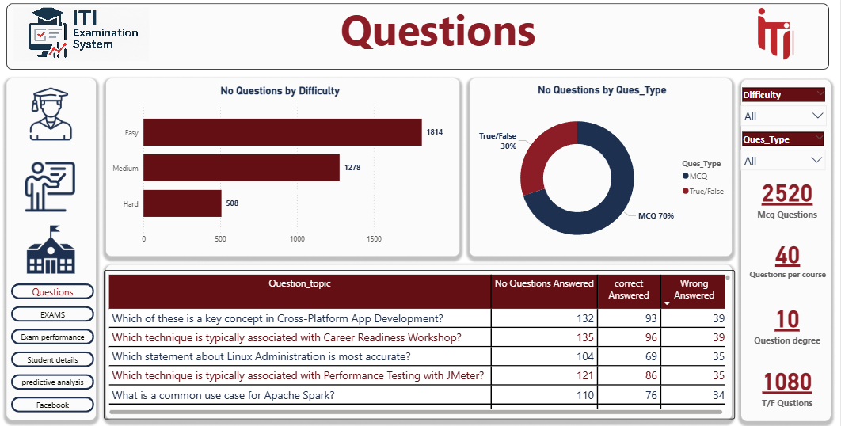

**Exam Dashboard 1**

Created to monitor exam performance, displaying student results, average scores.

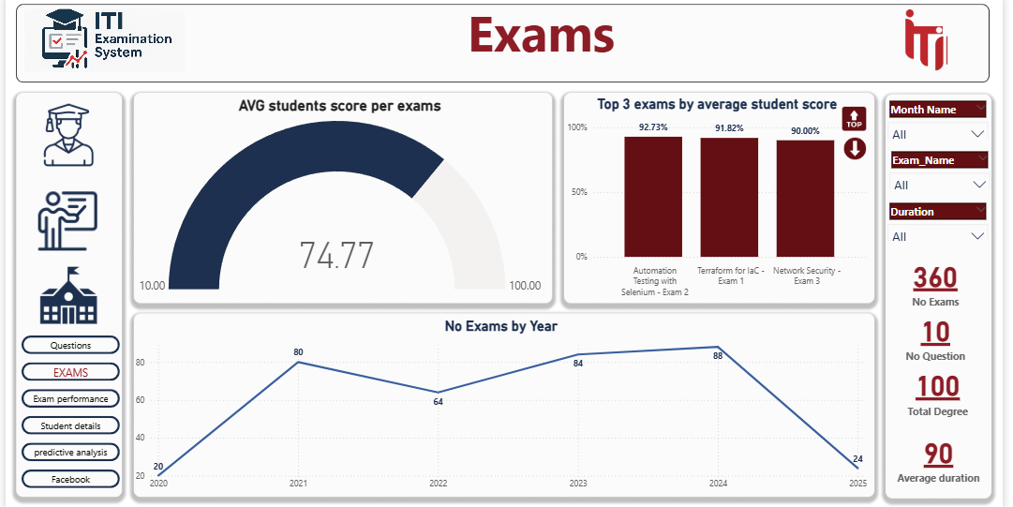

**Exam Dashboard 2**

A second exam dashboard was developed to provide deeper insights into exam analytics.

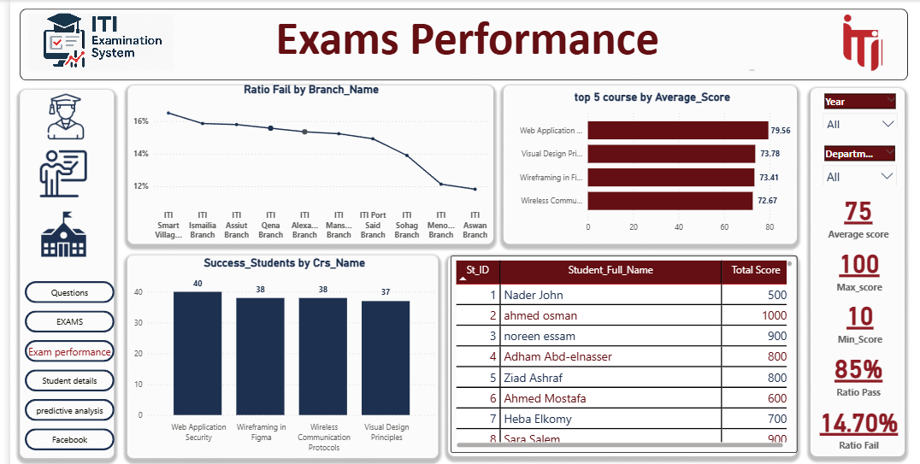

**Student Details**This dashboard presents detailed information about ITI students, including their names, intake types, departments, branches, tracks, and profile links.

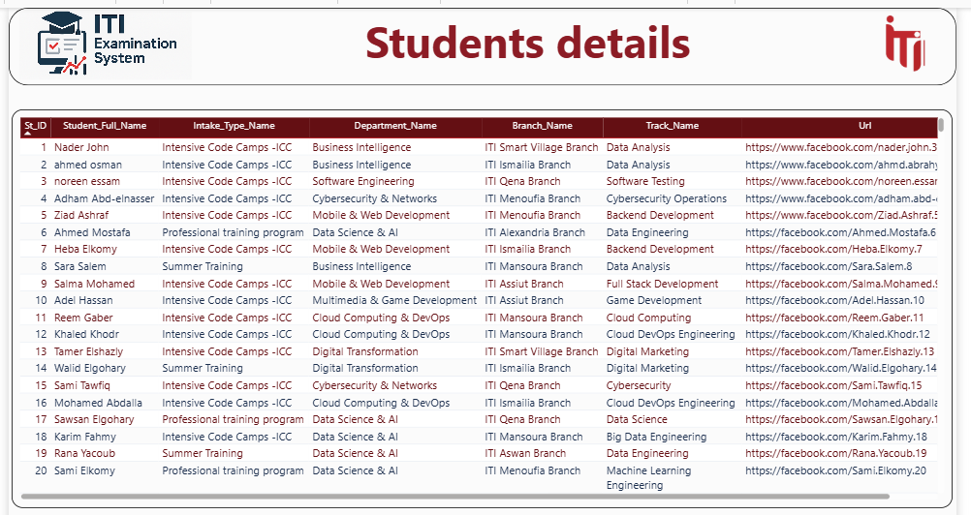

**Predictive Analysis**

Predict the total freelance revenue and number of students to forecast future trends in participation and revenue growth.

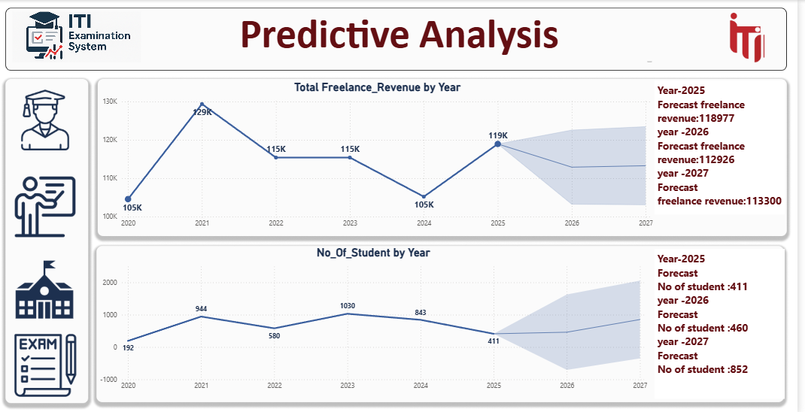

**Student Social Media**

Retrieve certain information from the student’s Facebook profile.

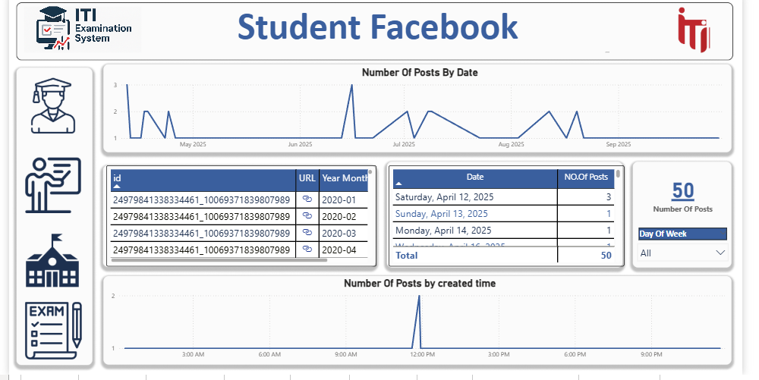

Website

The ITI Examination System is a modern and efficient platform designed to simplify online assessments for both students and instructors. It provides an all-in-one environment where students can take exams, access their results instantly, and track their academic progress. Instructors can effortlessly manage courses, create exams, and monitor student performance through an intuitive dashboard. With its clean interface and seamless functionality, the ITI Examination System ensures a smooth and organized examination process, promoting transparency, accuracy, and convenience for all users.

**Main Page**  
 A modern landing page that provides quick access to both the Student and Instructor portals for managing exams and results.   
  
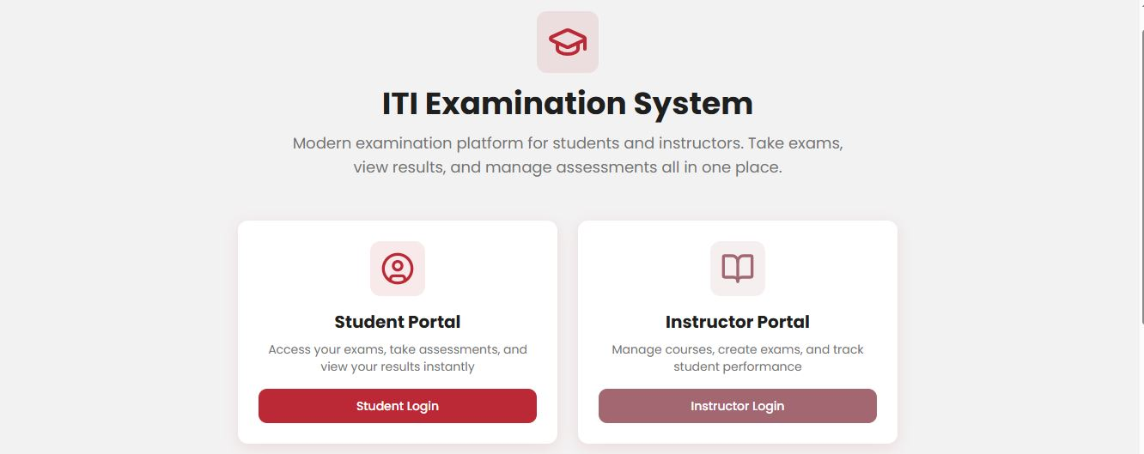

**Students Results**  
Displays detailed exam results for each student, including their scores, exam titles, and completion dates.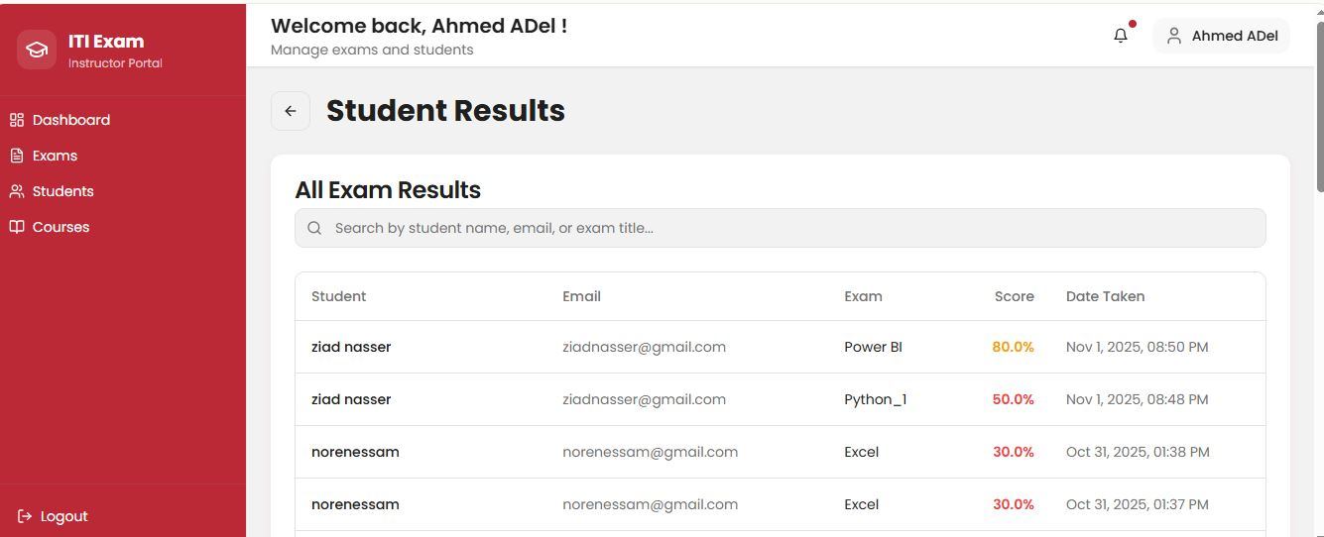  
**Manage Courses**  
Allows instructors to view, create, edit, and organize courses efficiently within the examination system.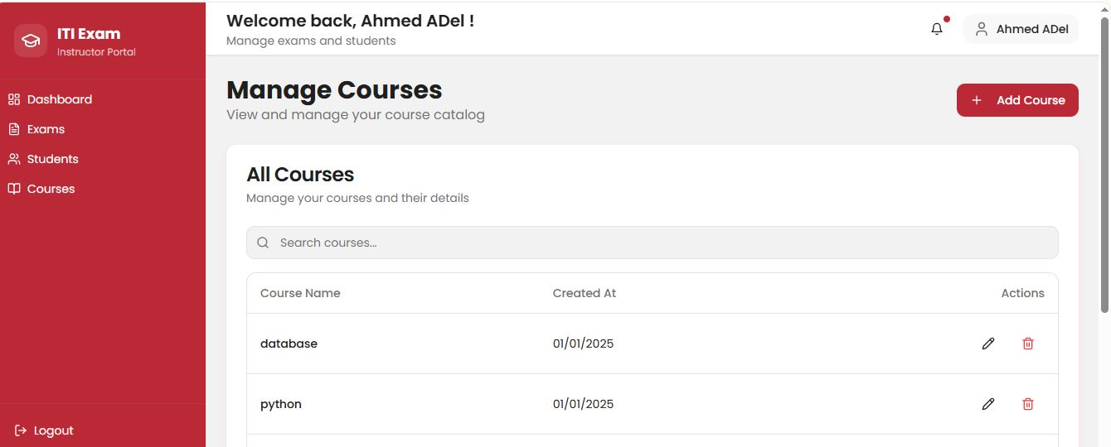

**Instructor Login**Secure access point for instructors to sign in and manage their courses, exams, and students.  
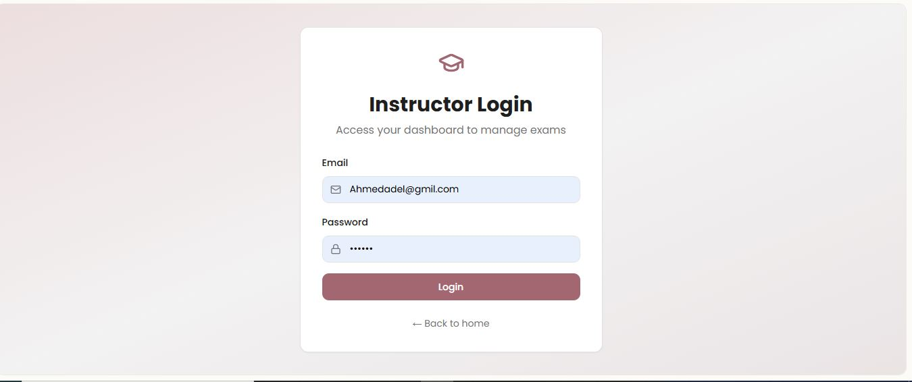

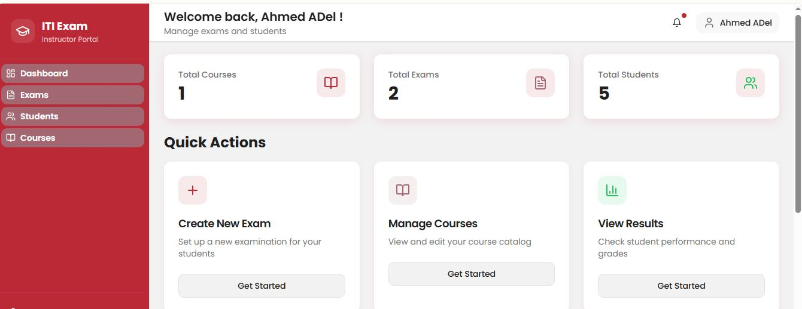

**Create Exam**Enables instructors to design and configure new exams by adding questions, setting durations, and assigning them to specific courses.

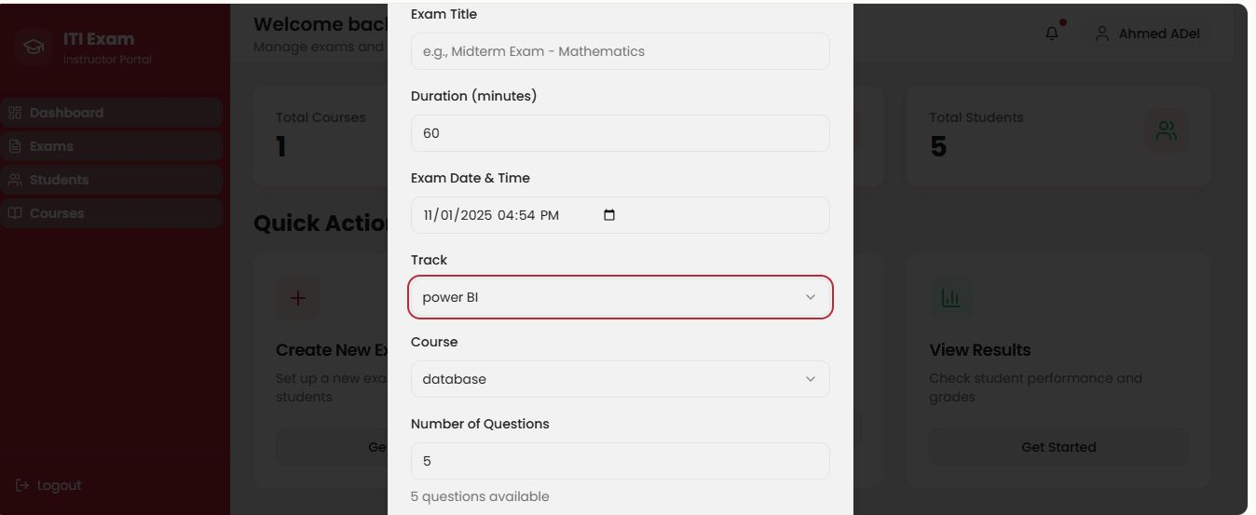

**Exams Page**Displays a complete list of all exams created by the instructor, with options to edit, delete, or assign them to students.

**Student Results**Provides a clear overview of each student’s performance, showing their scores, exam titles, and submission times.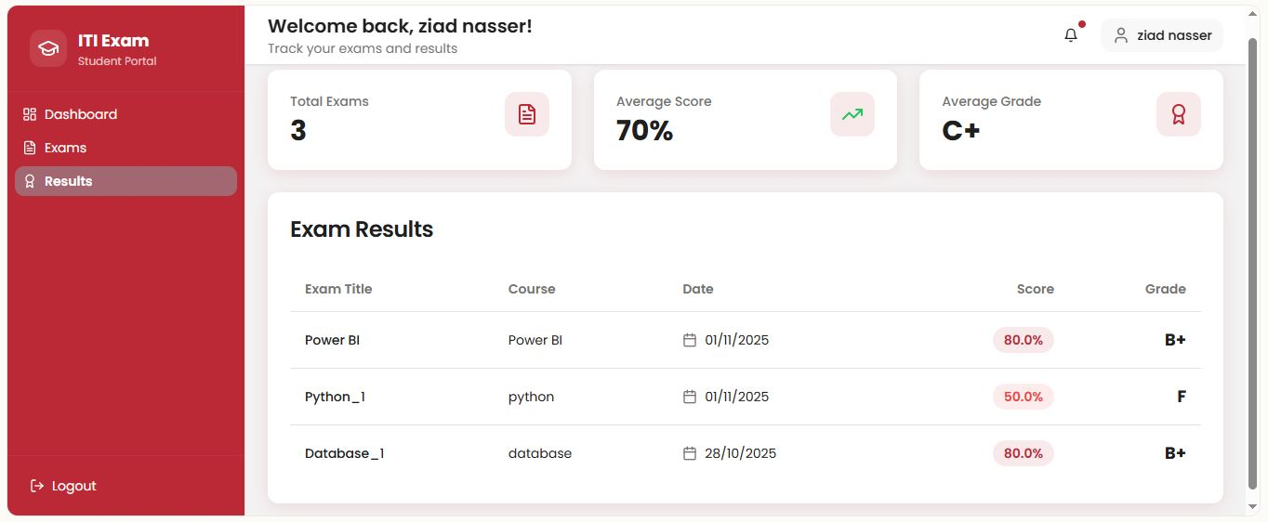

**Start Exam**  
Allows students to begin their online assessments through a user-friendly and timed examination interface.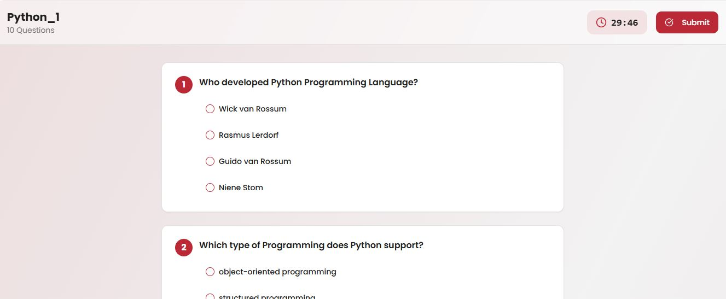

**Select Track**  
Lets users choose their training or specialization track before proceeding to related courses and assessments.